Practical 7: Configure IOS Intrusion Prevention System (IPS) Using the CLI
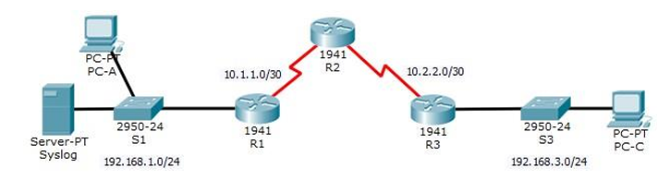
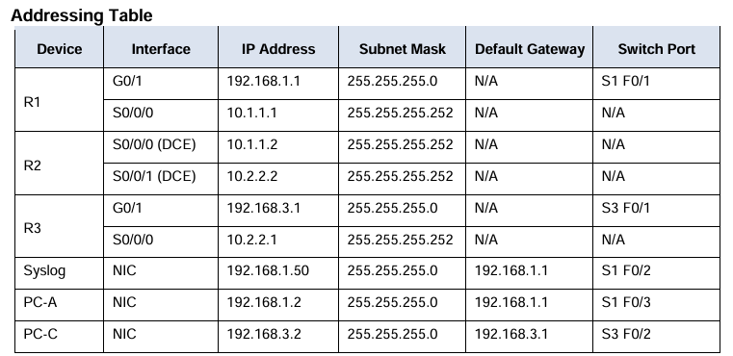

Objectives
• Enable IOS IPS.
• Configure logging.
• Modify an IPS signature.
• Verify IPS.

Routing
Router 1:
Router(config)#hostname R1
R1(config)#router rip
R1(config-router)#version 2
R1(config-router)#network 192.168.1.0
R1(config-router)#network 10.1.1.0

Router 2:
Router(config)#hostname R2
R2(config)#router rip
R2(config-router)#version 2
R2(config-router)#network 10.1.1.0
R2(config-router)#network 10.2.2.0

Router 3:
Router(config)#hostname R3
R3(config)#router rip
R3(config-router)#version 2
R3(config-router)#network 10.2.2.0
R3(config-router)#network 192.168.3.0

Part 1: Enable IOS IPS
Step 1: Enable the Security Technology package.
- On R1, issue the show version command to view the Technology Package license information.

R1#show version
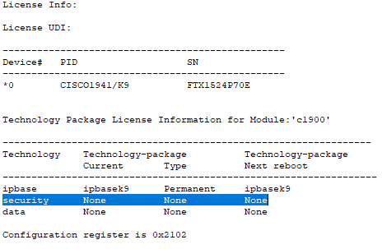
b. If the Security Technology package has not been enabled, use the following command to enable the package.
R1(config)#license boot module c1900 technology-package securityk9
c. Accept the end-user license agreement.
d. Save the running-config and reload the router to enable the security license.
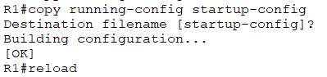
Press enter for destination filename
e. Verify that the Security Technology package has been enabled by using the show version command.
R1#show version
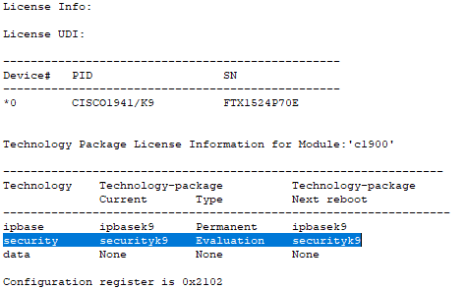

Step 2: Verify network connectivity.
a. Ping from PC-C to PC-A. The ping should be successful.
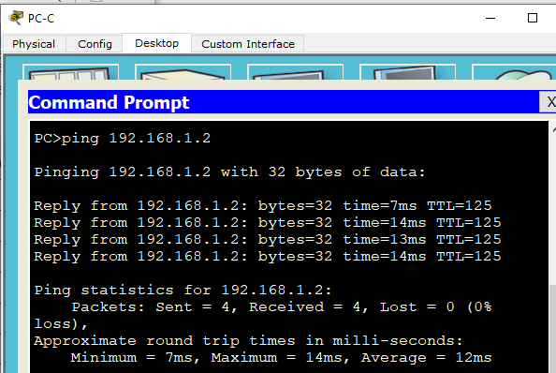

- Ping from PC-A to PC-C. The ping should be successful.
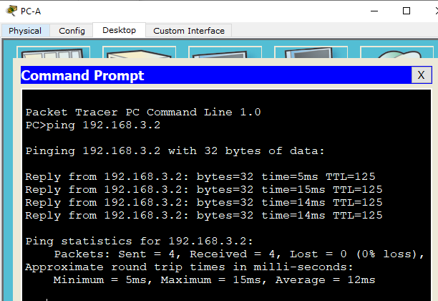
Step 3: Create an IOS IPS configuration directory in flash.

Step 4: Configure the IPS signature storage location.
R1(config)#ip ips config location flash:ipsdir
Step 5: Create an IPS rule.
R1(config)#ip ips name iosips
Step 6: Enable logging.
R1(config)# ip ips notify log
R1#clock set 16:20:10 8 feb 2026
R1(config)#service timestamps log datetime msec
R1(config)#logging host 192.168.1.50
Step 7: Configure IOS IPS to use the signature categories.
R1(config)#ip ips signature-category
R1(config-ips-category)#category all
R1(config-ips-category-action)#retired true
R1(config-ips-category-action)#exit
R1(config-ips-category)#category ios_ips basic
R1(config-ips-category-action)#retired false
R1(config-ips-category-action)#exit
R1(config-ips-category)#exit
Do you want to accept these changes? [confirm] <enter>
Step 8: Apply the IPS rule to an interface.
R1(config)#interface gigabitEthernet 0/1
R1(config-if)#ip ips iosips out

Part 2: Modify the Signature
Step 1: Change the event-action of a signature.
R1(config)#ip ips signature-definition
R1(config-sigdef)#signature 2004 0
R1(config-sigdef-sig)#status
R1(config-sigdef-sig-status)#retired false
R1(config-sigdef-sig-status)#enabled true
R1(config-sigdef-sig-status)#exit
R1(config-sigdef-sig)#engine
R1(config-sigdef-sig-engine)#event-action produce-alert
R1(config-sigdef-sig-engine)#event-action deny-packet-inline
R1(config-sigdef-sig-engine)#exit
R1(config-sigdef-sig)#exit
R1(config-sigdef)#exit
Do you want to accept these changes? [confirm] <enter>
Step 2: Use show commands to verify IPS.
R1#show ip ips all

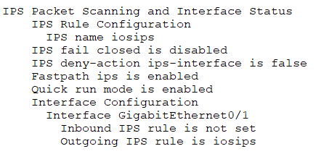
Step 3: Verify that IPS is working properly.
- From PC-C, attempt to ping PC-A.
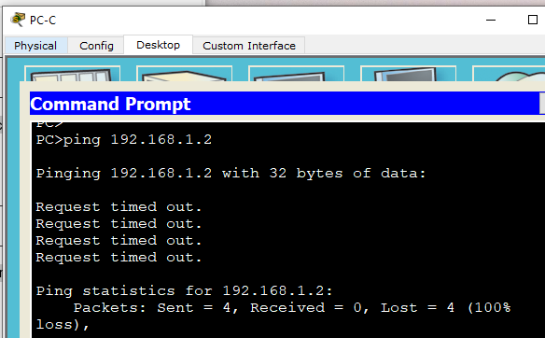
- From PC-A, attempt to ping PC-C

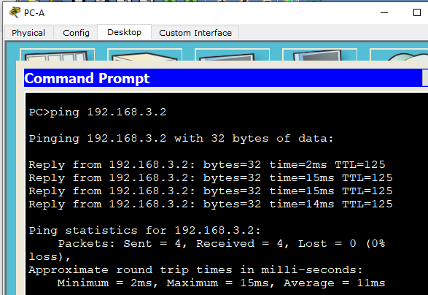
Step 4: View the syslog messages.
a. Click the Syslog server.
b. Select the Services tab.
c. In the left navigation menu, select SYSLOG to view the log file.
